# Grazioso Salvare Dashboard

Developer: Damon Harris

Course: SNHU CS-340

Client: Global Rain / Grazioso Salvare

Purpose: This project provides an interactive dashboard for identifying and filtering dogs from a regional animal shelter database based on their suitability for search-and-rescue training.

## Project Overview

This dashboard allows users at Grazioso Salvare to:  
- View shelter data for available dogs  
- Filter dogs by rescue type (water, disaster, tracking, etc.)  
- View data in an interactive table  
- See each dog’s location on a Leaflet map  
- View a pie chart of breed distribution  
- Easily identify dogs younger than 2 years old and of preferred breeds  
  
The dashboard was built using:  
- Python  
- Dash (Plotly Dash + Dash Leaflet)  
- MongoDB  
- CRUD Python module (custom)  
- JupyterDash (for Jupyter notebook compatibility)

## Features

- CRUD operations powered by crud_module.py  
- Dropdown filter for rescue types (Water, Disaster, Wilderness, Tracking)  
- Map showing the selected animal’s location  
- Pie chart for breed distribution  
- "Show All" option to reset filters  
- Grazioso Salvare logo and developer ID  
- Interactive layout built using MVC design principles

## Setup Instructions

Prerequisites:

- Python 3.8+  
- MongoDB (configured on Apporto or local)  
- Jupyter Notebook or VS Code  
- Dependencies:  
 pip install dash dash-leaflet jupyter-dash pandas plotly pymongo

## Project Files

dashboard_app.py - Main Dash app file  
crud_module.py - Contains the AnimalShelter class for MongoDB interaction  
grazioso_logo.png - Logo displayed in the dashboard  
README.docx - Project documentation  
screenshots/ - Folder containing required screenshots

## Screenshots

Main MongoDB Connection:

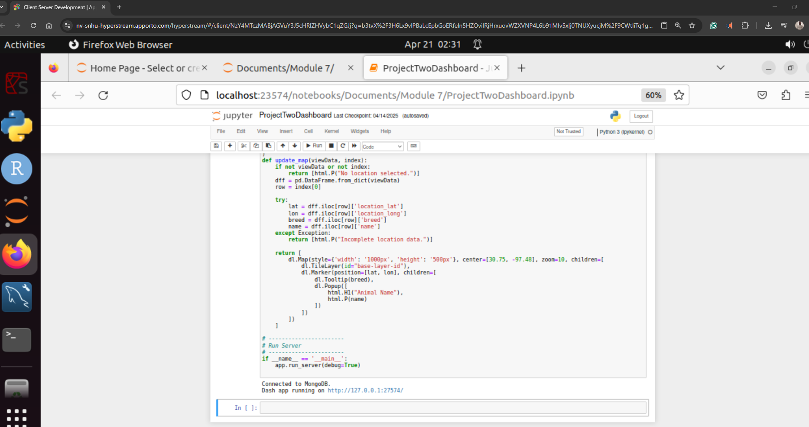

1. Dashboard Home View - dashboard_main.png

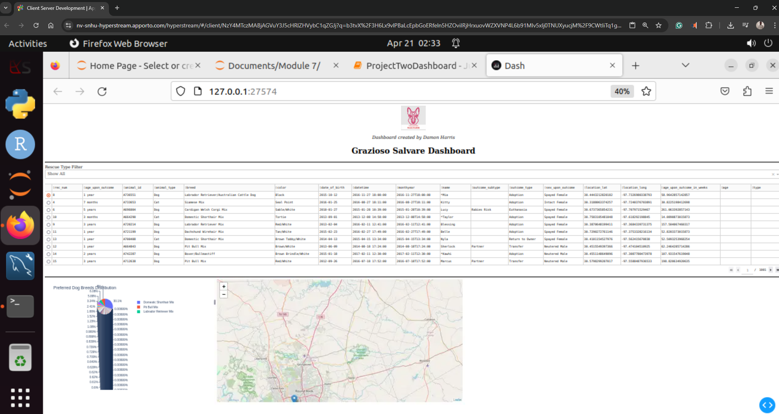

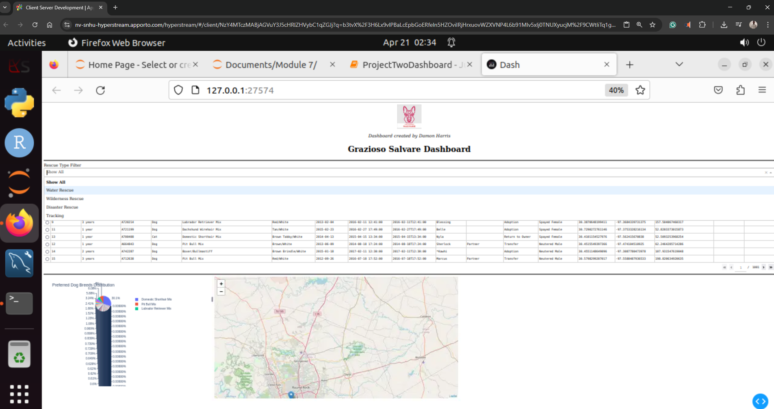

1. Filter by Water Rescue - filter_water.png

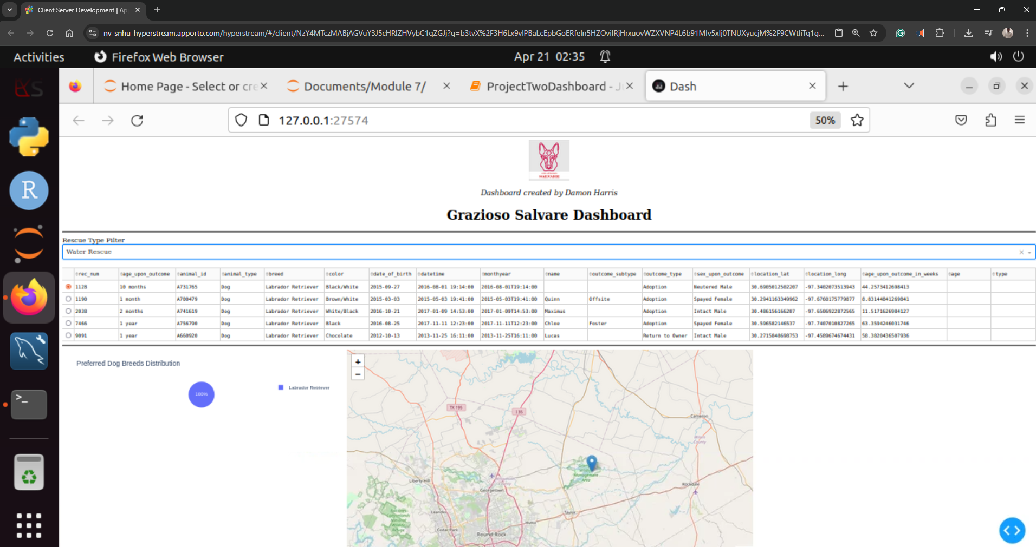

1. Map Update Based on Selection - map_update.png

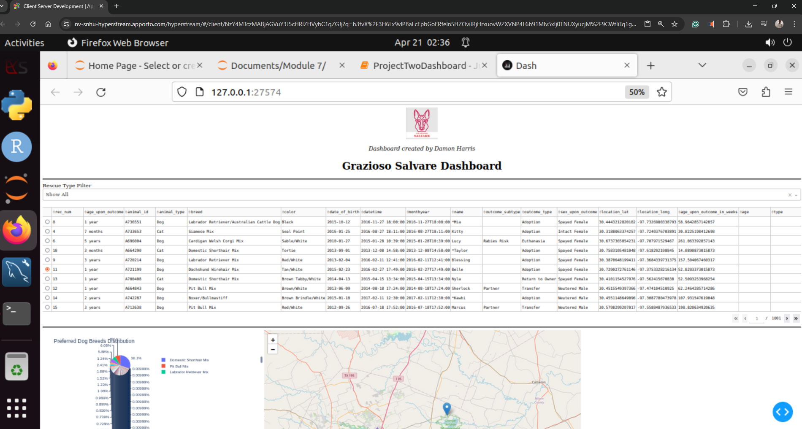

1. Pie Chart of Breeds - pie_chart.png

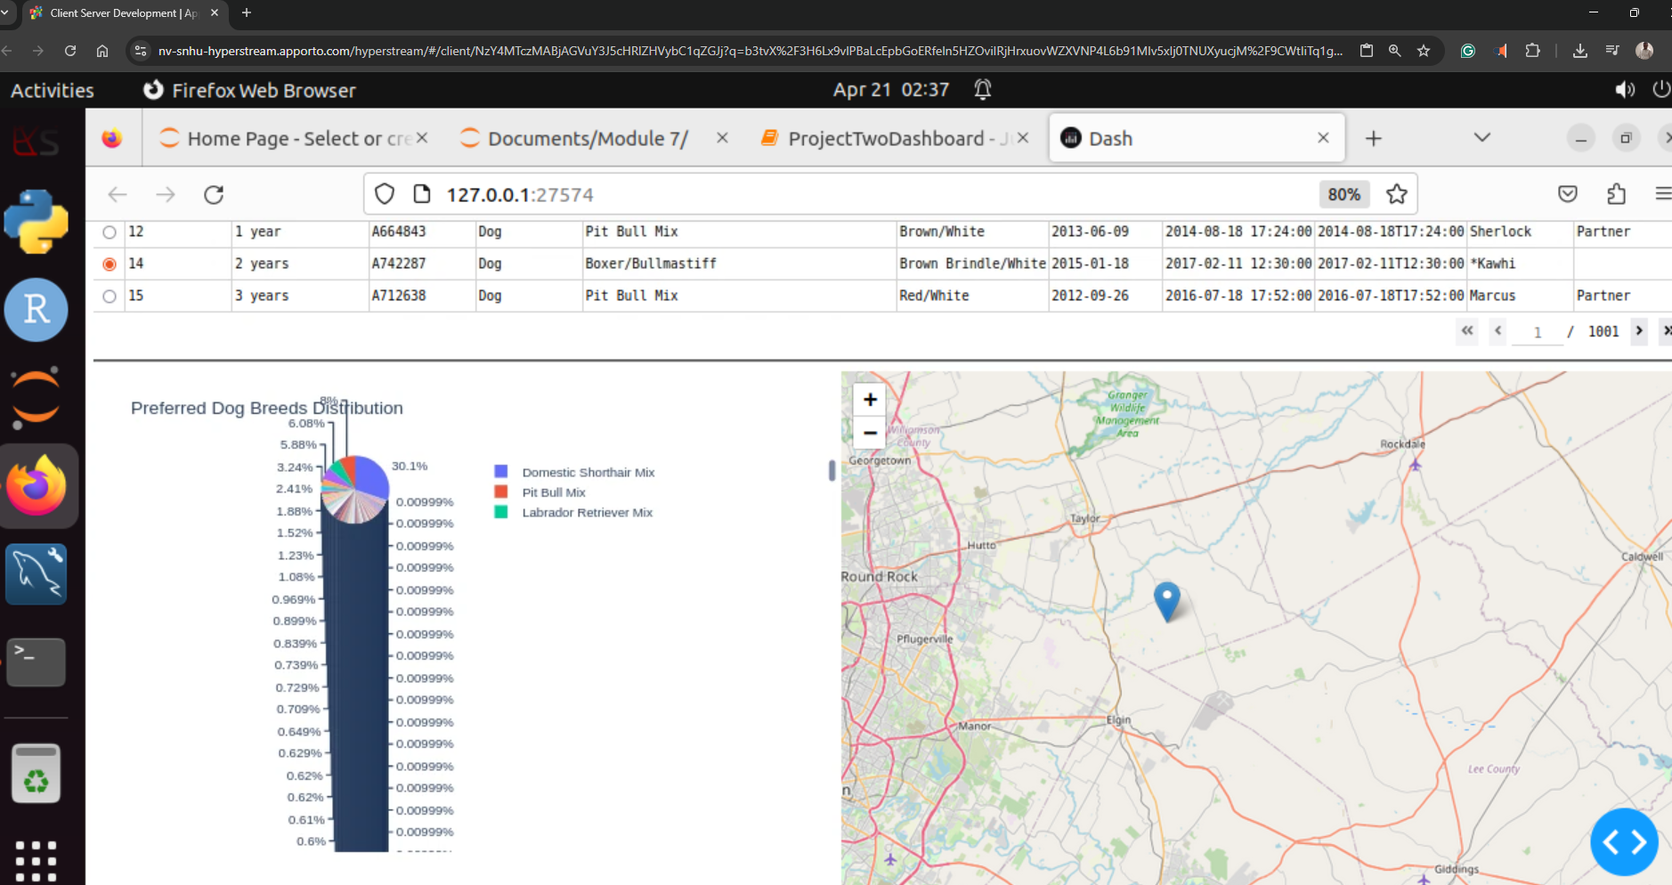

1. Logo & Developer ID - logo_display.png

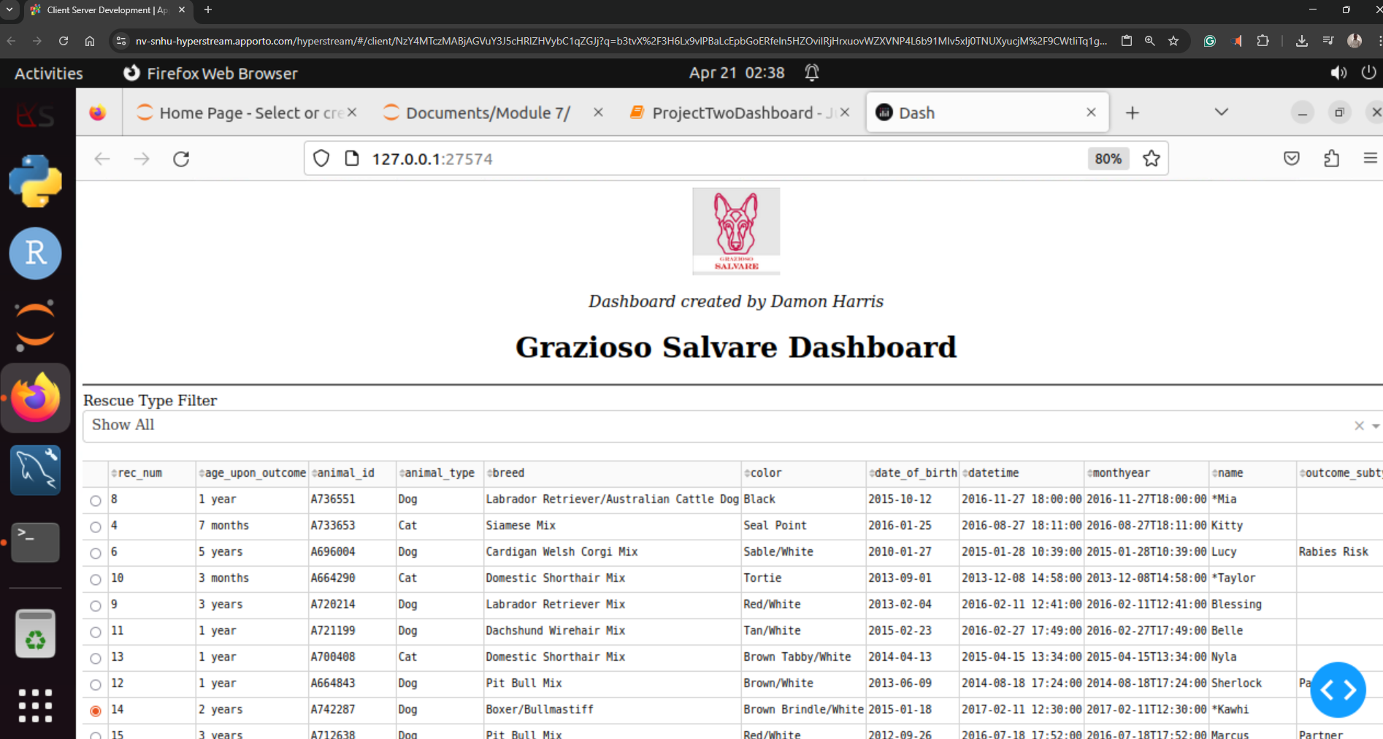

## How to Run

1. Place all project files in the same folder.  
2. Launch dashboard_app.py from a Jupyter notebook or a Python IDE.  
3. Make sure MongoDB is running and accessible.  
4. The app will open at http://127.0.0.1:8050/

## Data Source

This app connects to the AAC Animal Shelter MongoDB collection, provided by SNHU and imported using mongoimport.

## Acknowledgements

- Thanks to the SNHU CS-340 team for guidance  
- Logo and dataset provided by course materials  
- Built with love for animal rescue 🐕